Disability Awareness Month 2025

We’re Here All Year

Meet Us. Know Us. Involve Us.

Disability Awareness Poster Contest

Since the month of March is, Disability Awareness Month MCSDD would like to sponsor a poster contest.



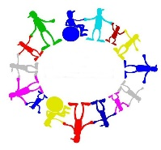

Design a poster that shows how individuals with developmental disabilities are here all year long. It could be an individual doing sports, working, playing or being involved in the community. The ideas are endless. Your poster should be no bigger than 11X17. It does not need to be framed. Posters will need to be received by March 17, to be entered into the contest. Posters will displayed in the Activity Room, at MCSDD from March 7 through March 31. You can drop them off at MCSDD at the receptionist desk. Posters can be picked up between April 2 and April 9. After April 9, the remainder posters will be disposed of. The winner of the poster contest will be announced March 26.

Please fill out the Release Form and put your name on the back of your poster. For more information, contact Kathy by phone or text at 712-355-0012.